**Section 1**:  
  
LSTM and Monte Carlo simulation are two distinct approaches for stock prediction, each with their own unique principles and methodologies. In the realm of stock forecasting, let's delve into the major contrasts between these strategies: LSTM, a type of recurrent neural network (RNN), is specifically designed to comprehend and learn long-term connections in sequential data. As a result, it is highly effective in predicting time-series data such as stock prices. Learning intricate patterns and connections within historical stock price data, LSTM models are capable of forecasting future prices with precision. Additionally, they take into account temporal dependence in the data, enabling them to capture trends, seasonality, and other time-related patterns. This is in stark contrast to the Monte Carlo simulation, which operates on a completely different premise. The training process for LSTM models is its own, distinct procedure, further emphasizing its unique approach to stock prediction. Where Monte Carlo simulation is a powerful statistical technique that involves generating numerous random samples to represent the probability distribution of potential outcomes. It is commonly utilized in uncertainty modelling to assess the variability of stock prices, by sampling from probability distributions of important factors like volatility and returns. Unlike LSTM models, which learn from past data, Monte Carlo simulation allows for the exploration of possible future scenarios based on assumed probability distributions. This makes it a versatile tool for scenario analysis. What sets it apart is that it does not rely on learning from historical patterns or training on specific datasets, but rather on assumptions about the statistical properties of the data.

The world of stock prediction is both intriguing and demanding, blending the realms of finance, data science, and machine learning to accurately anticipate shifts in financial markets. It is a subject of great interest to both investors and traders, who rely on stock price forecasts to make wise choices, capitalize on opportunities, and effectively manage risks. The driving force behind stock prediction lies in its potential to provide a competitive edge in financial markets, achieved through the analysis of past trends, market indicators, and sophisticated algorithms. The realm of stock prediction presents a unique challenge due to the ever-changing nature and intricacies of financial markets. Numerous factors such as economic indicators, company performance, global events, and investor sentiment, all have a profound impact on stock prices. To effectively tackle these challenges, it is crucial to employ specialized techniques and tools.

<https://medium.com/@arunp77/monte-carlo-simulation-828a463b8772>

<https://medium.com/@polanitzer/forward-looking-monte-carlo-simulation-predict-the-future-value-of-equity-using-the-lognormal-f54320f9c230>

<https://gist.github.com/jkclem/b16f9d8cd0a9e817fd3baa3ce3cd0194>

<https://medium.com/the-handbook-of-coding-in-finance/stock-prices-prediction-using-long-short-term-memory-lstm-model-in-python-734dd1ed6827>

<https://github.com/Jatin-Goyal-552/Stock_Price_Predicton>

**Section2:**

While both MinMaxScaler and the MinMax algorithm serve the purpose of scaling data, they do so in distinct ways. Taking a cue from the world of dance, MinMaxScaler can be likened to a dedicated dance instructor, skilled in using the power of scikit-learn to make your numbers groove between 0 and 1 by resizing and adjusting them. On the other hand, the MinMax algorithm is like a versatile dance guru, capable of scaling your data to any desired range - not just 0 to 1. drew inspiration from our recent class and implemented these scaling techniques in my stock price prediction project. Applying MinMaxScaler allowed me to normalize the stock data, squeezing it into a consistent 0 to 1 range. Meanwhile, the MinMax algorithm became my go-to for more customized scaling, enabling me to adapt the data to specific desired ranges. So, MinMaxScaler is the specialist for 0 to 1, while the MinMax algorithm is the versatile expert for custom scaling ranges, and I found them both invaluable in tailoring my stock prediction models.  
  
  
  
In the presented code, the goal is to predict stock prices using two different approaches: Long Short-Term Memory (LSTM) and Monte Carlo Simulation. LSTM is a type of neural network designed for time-series prediction, and it is implemented using the TensorFlow and Keras libraries. The code starts by loading historical stock data of Apple Inc. (AAPL) from a CSV file and then preprocesses the data. The LSTM model is trained on a portion of the data and validated on the remaining part. Subsequently, the model is used for predicting future stock prices.

On the other hand, Monte Carlo Simulation is a statistical method used to model the probability distribution of possible outcomes. In this context, it generates multiple simulations of future stock prices based on the historical mean and standard deviation of daily returns. The simulations provide a range of potential future stock price scenarios, allowing for risk analysis and decision-making.

**Metric Definition:**

To quantitatively evaluate the performance of the LSTM model, the Root Mean Squared Error (RMSE) is employed as the metric. RMSE measures the average magnitude of the differences between predicted and actual stock prices. It is defined by the equation:

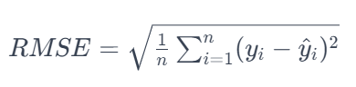

where *n* is the number of data points, *yi*​ is the actual stock price at time *i*, and *y*^​*i*​ is the predicted stock price at time *i*. The lower the RMSE, the better the model's predictive performance.

Monte carlo is used for risk analysis.

**Model Evaluation:**

The implementation correctness of the algorithms can be assessed by examining the RMSE values calculated for both training and test datasets. The RMSE values are computed for both LSTM and Monte Carlo Simulation predictions. If the code is implemented correctly, lower RMSE values indicate a better fit between predicted and actual stock prices, signifying the efficacy of the respective algorithms in capturing and predicting stock price movements.

In addition to quantitative metrics, visual inspection is performed through plots to compare the predicted stock prices against the actual values. The code also incorporates statistical analyses, such as mean returns, volatility clustering, and scenario analysis, to provide a comprehensive evaluation of the algorithms' performance and risk.

**Monte Carlo Simulation Formula:**

Monte Carlo Simulation is a probabilistic method involving the generation of multiple random samples to model the probability distribution of potential outcomes. For predicting stock prices, the simulation employs the geometric Brownian motion formula, a stochastic differential equation representing the dynamics of stock prices. The formula is expressed as:

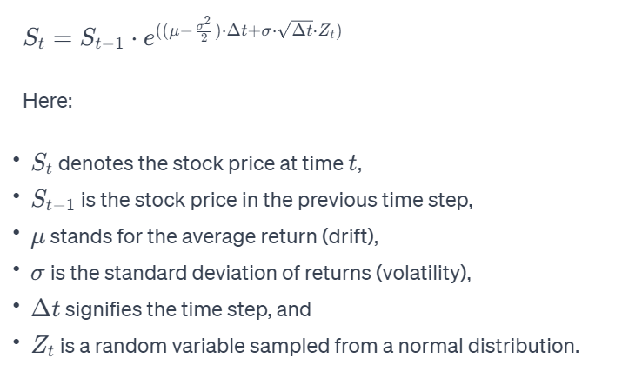

* .

**Drift Formula:**

The drift term in the geometric Brownian motion formula represents the average return adjusted for half of the squared volatility. This term factors in the expected trend in the stock price, considering the average historical return and adjusting for the impact of volatility. The formula for drift is articulated as:

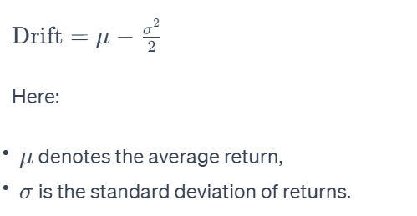

**Percentage Change Formula:**

In the realm of stock market analysis, calculating the percentage change in stock prices is a prevalent metric. The percentage change formula is outlined as:

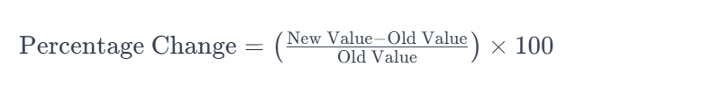

This formula computes the percentage difference between a new value (such as the current stock price) and an old value (like the previous day's closing price). It serves as a fundamental metric for comprehending the relative change in stock prices over a specific period. These formulas play pivotal roles in both Monte Carlo Simulation and traditional financial analyses, offering a quantitative framework for modeling stock price dynamics, evaluating trends, and assessing the impact of market variables on financial instruments in an Indian context.

**Why you use two algorithms ? if ask**

LSTM, being a neural network-based method, is great for understanding detailed patterns and trends in time-series data, like stock prices. Its flexibility lets it learn from past data, uncovering complex relationships and making it a strong tool for predicting future stock movements.

Now, Monte Carlo Simulation is like a statistical storyteller. It creates a bunch of possible future scenarios based on past data, giving us a sense of uncertainty and risk in future stock prices. It's like looking at different ways the story could unfold.

Putting these two together gives us a complete picture of stock market prediction. LSTM is like a short-term trend-spotter, catching quick movements, while Monte Carlo Simulation explores different statistical stories, helping us see the bigger picture of potential long-term market movements. This mix of both methods creates a well-rounded approach, using the strengths of each to make our stock prediction model more solid and trustworthy.

**Code Explination.**

# Import necessary libraries

import pandas as pd

import numpy as np

import matplotlib.pyplot as plt

import seaborn as sns

# Read the CSV file

df = pd.read_csv('AAPL.csv')

Here, the required libraries are imported, and the Apple stock data is loaded into a Pandas DataFrame (df). The dataset is assumed to contain columns like 'date', 'adjClose', etc.

# Select 'close' column and scale the values

df1 = df.reset_index()['close']

from sklearn.preprocessing import MinMaxScaler

scaler = MinMaxScaler(feature_range=(0, 1))

df1 = scaler.fit_transform(np.array(df1).reshape(-1, 1))

The 'close' prices are selected and scaled between 0 and 1 using Min-Max scaling to improve model convergence.

# Split the dataset into training and test sets

training_size = int(len(df1) * 0.65)

test_size = len(df1) - training_size

train_data, test_data = df1[0:training_size, :], df1[training_size : len(df1), :1]

The dataset is split into training and test sets. The training set contains 65% of the data, and the test set contains the remaining 35%.

# Create input sequences for LSTM

def create_dataset(dataset, time_step=1):

dataX, dataY = [], []

for i in range(len(dataset) - time_step - 1):

a = dataset[i : (i + time_step), 0]

dataX.append(a)

dataY.append(dataset[i + time_step, 0])

return np.array(dataX), np.array(dataY)

This function prepares the data for LSTM training by creating input sequences (**dataX**) and their corresponding labels (**dataY**).

# Reshape the input sequences

time_step = 100

X_train, y_train = create_dataset(train_data, time_step)

X_test, ytest = create_dataset(test_data, time_step)

X_train = X_train.reshape(X_train.shape[0], X_train.shape[1], 1)

X_test = X_test.reshape(X_test.shape[0], X_test.shape[1], 1)

The sequences are reshaped to fit the LSTM model input requirements.

# Create an LSTM model

from tensorflow.keras.models import Sequential

from tensorflow.keras.layers import Dense, LSTM

model = Sequential()

model.add(LSTM(50, return_sequences=True, input_shape=(100, 1)))

model.add(LSTM(50, return_sequences=True))

model.add(LSTM(50))

model.add(Dense(1))

This code defines an LSTM model with three layers and compiles it using the mean squared error loss function.

# Train the LSTM model

model.fit(X_train, y_train, validation_data=(X_test, ytest), epochs=100, batch_size=64, verbose=1)

The model is trained on the training data for 100 epochs.

# Perform predictions on training and test data

train_predict = model.predict(X_train)

test_predict = model.predict(X_test)

The trained model is used to make predictions on both the training and test datasets.

# Transform predictions back to original scale

train_predict = scaler.inverse_transform(train_predict)

test_predict = scaler.inverse_transform(test_predict)

The predicted values are transformed back to the original scale for better interpretation.

# Calculate RMSE for training and test data

from sklearn.metrics import mean_squared_error

math.sqrt(mean_squared_error(y_train, train_predict))

math.sqrt(mean_squared_error(ytest, test_predict))

The Root Mean Squared Error (RMSE) is calculated to evaluate the model's performance on both training and test data.

# Plotting the predictions

plt.plot(scaler.inverse_transform(df1))

plt.plot(trainPredictPlot)

plt.plot(testPredictPlot)

plt.show()

This code visualizes the actual stock prices along with the predicted prices on both the training and test datasets.

# Monte Carlo Simulation

daily_returns = adj_close.pct_change()

mu = daily_returns.mean()

sigma = daily_returns.std()

num_simulations = 1000

num_days = 10

simulations = np.zeros((num_simulations, num_days))

for i in range(num_simulations):

daily_returns_sim = np.random.normal(mu, sigma, num_days)

price_sim = adj_close[-1] * np.exp(np.cumsum(daily_returns_sim))

simulations[i, :] = price_sim

This section sets up and performs a Monte Carlo Simulation on the stock prices using historical daily returns.

# Plot the Monte Carlo Simulation results

plt.figure(figsize=(12, 8))

cmap = plt.cm.viridis

for i in range(num_simulations):

plt.plot(simulations[i, :], color=cmap(i / num_simulations), alpha=0.1)

plt.title('Monte Carlo Simulation - AAPL Stock Price')

plt.xlabel('Days')

plt.ylabel('Simulated Stock Price')

plt.show()

The results of the Monte Carlo Simulation are plotted with different colors for each simulation.

# Statistical Analysis of Simulated Stock Prices

mean_prices = simulations.mean(axis=0)

median_prices = np.median(simulations, axis=0)

quantiles = np.percentile(simulations, [10, 90], axis=0)

plt.figure(figsize=(12, 8))

plt.plot(mean_prices, label='Mean')

plt.plot(median_prices, label='Median')

plt.fill_between(range(num_days), quantiles[0, :], quantiles[1, :], alpha=0.3, label='10-90 Percentile Range')

plt.title('Statistical Analysis of Simulated Stock Prices')

plt.xlabel('Days')

plt.ylabel('Stock Price')

plt.legend()

plt.show()

Statistical analysis is performed on the simulated stock prices, including mean, median, and the 10-90 percentile range.

# Distribution plot of the final simulated prices

final_prices = simulations[:, -1]

plt.figure(figsize=(10, 6))

sns.histplot(final_prices, bins=30, kde=True)

plt.title('Distribution of Simulated Final Stock Prices')

plt.xlabel('Final Stock Price')

plt.ylabel('Frequency')

plt.show()

A distribution plot is created for the final simulated stock prices, providing an overview of possible outcomes.

# Risk-Return Analysis

returns = (simulations[:, -1] - adj_close[-1]) / adj_close[-1]

risk = np.percentile(returns, 5)

expected_return = np.mean(returns)

print(f"Expected Return: {expected_return:.4f}")

print(f"Risk (5th Percentile): {risk:.4f}")

Risk and return analysis is performed on the simulated returns, calculating the expected return and risk.

# Volatility Clustering Analysis

rolling_volatility = daily_returns.rolling(window=20).std()

plt.figure(figsize=(12, 6))

plt.plot(rolling_volatility, label='Rolling Volatility ')

plt.title('Volatility Clustering - AAPL Stock')

plt.xlabel('Date')

plt.ylabel('Volatility')

plt.legend()

plt.show()

Volatility clustering analysis is performed by plotting the rolling volatility of the stock returns.

# Scenario Analysis

scenario_returns = simulations[:, -1] / adj_close[-1] - 1

scenario_returns_sorted = np.sort(scenario_returns)

plt.figure(figsize=(12, 6))

plt.plot(scenario_returns_sorted, color='red', label='Scenario Returns')

plt.axvline(np.percentile(scenario_returns, 5), color='blue', linestyle='dashed', label='5th Percentile')

plt.axvline(np.percentile(scenario_returns, 95), color='green', linestyle='dashed', label='95th Percentile')

plt.title('Scenario Analysis - Simulated Returns')

plt.xlabel('Scenario')

plt.ylabel('Returns')

plt.legend()

plt.show()

Scenario analysis is performed by plotting the sorted returns from simulations and marking the 5th and 95th percentiles.